Praveen Kumar. D
Email: praveendevaragudimc@gmail.com Phone: +91-9347600680
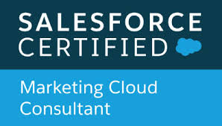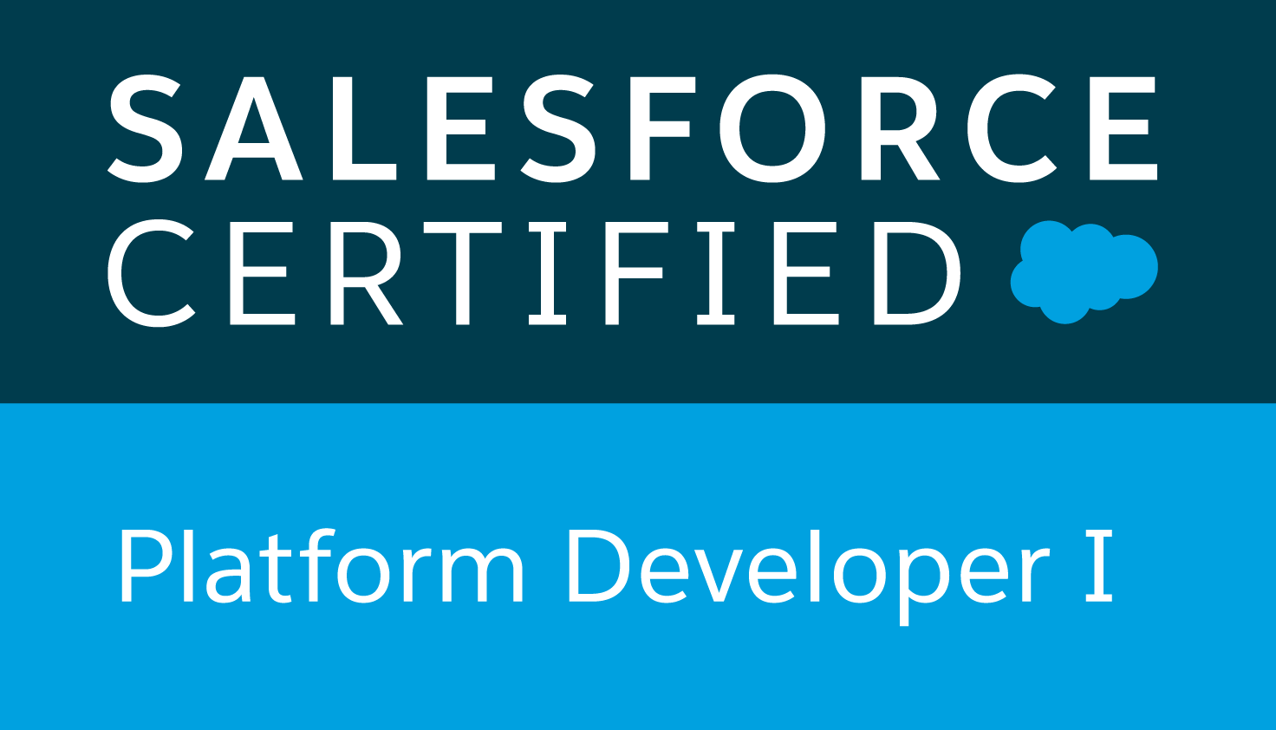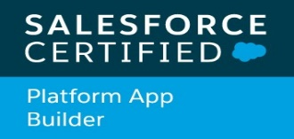

PROFESSIONAL SUMMARY
- Having 8 years of IT professional experience in Salesforce Marketing Cloud and Salesforce.com, I have worn many hats in the last 8 years as Salesforce Marketing Cloud Developer and Salesforce sales cloud and service cloud admin and developer.

- Having 6 years of experience in Salesforce Marketing Cloud and 2 years experience in Salesforce sales cloud and service cloud.

Salesforce Marketing Cloud:

- Involved in gathering the requirements and analysis on specifications. Excellent Knowledge of SQL queries.
- Worked on Data extensions, Shared and Synchronized Data Extensions.
- Used FTP accounts and automation studio to send the email and also to maintain the data by using the SQL query activities.
- Hands-on experience on AMP script, HTML.
- Experience in creating Contents, Templates, HTML emails and Template based emails.
- Worked on Automation Studio to send email, and to trigger the journey for sending emails.
- Extensively worked on Mobile Connect requirements.
- Handled requirements of sending messages with text and personalized content.
- Knowledge on Ampscript to use it in Email Studio, Mobile Connect and Cloud Pages.
- Extensive knowledge in debugging in all the issues occur in journey builder, mobile connect, email studio and automation studio.
- Worked on Cloud Pages to update data extensions and salesforce objects.
- Having good knowledge on Data Model attribute groups and linking the data extensions as per the requirements in journey builder.
- Good knowledge in troubleshooting the issues on Journey’s, SQL queries and Cloud pages.
- Extensive knowledge on Contact Builder and Attribute Groups.

Salesforce:
- Experience on sales and service cloud projects. Experience in creating reports as per the client’s requirement.
- Worked on Lead, Account, Opportunity, Case and Campaign objects.
- Experience in configuring the profiles, roles, page layouts and field accessibility.
- Developed triggers, batch classes as per the requirement.
- Worked on Workflow Rules, Validations and Process Builder.
- Worked on rest API expose services.
- Integrated between salesforce to salesforce and salesforce to third party systems/websites.

Certifications
- Certified in Salesforce Marketing Cloud Email Specialist.
- Certified in Salesforce Marketing Cloud Consultant.
- Certified in Salesforce Administrator.
- Certified in Platform Developer 1.
- Certified in Platform App Builder.

WORK EXPERIENCE
- Working in ‘Optum Global Solutions’ from 19th July 2021 to till date.
- Worked in ‘GUS Education India’ from 10th June 2019 to July 2021.
- Worked in ‘Salesforce.com India Pvt Ltd’ from 23rd January 2017 to 31st May 2019.
- Worked as Application Development Analyst for ' Accenture Solutions Pvt Ltd ' from April 30th 2015 to 16th January 2017.

education qualification
- B.Tech in Information Technology from 'Sree Rama Engineering College' affiliated to JNTUA University.

PROFESSIONAL EXPERIENCE
Project Details:

Client : John Muir Health
Role : SFMC Developer
Tools : Zapier.

Description: John Muir Health is a hospital network in United States. JMH uses salesforce platforms Sales cloud and Marketing Cloud to manage patients and provider’s. JMH uses marketing cloud to send the welcome emails to the new patients and to manage it’s MyChart account activations.
Responsibilities:
- Integration between the salesforce and the marketing cloud.
- Understanding the business requirement and made analysis on attribute groups that needs to have the relationships between the data extensions which satisfies the requirement.
- Worked on Journey builder requirement and the related issues.
- Worked on different activities like SQL, File transfer and Email send etc.
- Extensively worked on journey builder for sending emails, sms and other activities of journeys.

Client : GUS Education India (Internal Project)
Role : SF Developer
Tools : Zapier.

Description: Gus Education India is an education based organisation which owns universities in multiple countries. It offers different courses in different universities to the students. We use Marketing Cloud and Salesforce to maintain student data and to send promotional and personalized emails, sms and triggered emails based on the student action.
Responsibilities:
- Working on the POC’s and requirements gathering.
- Worked on Amp script to personalize emails and sms messages.
- Worked on Mobile Connect requirements.
- Worked on Journey builder requirements and the related issues.
- Worked on Journey Builder and Automation studio that helps to the students to get the related information regarding their course.
- Integrated the salesforce and the marketing cloud.
- Worked on Contact Builder and Attribute Groups.
- Worked on different activities like SQL, File transfer and Email send etc.

Project Details:

Client : Global client’s and Partners of Salesforce.com
Role : SF Developer
Tools : Salesforce Internal Tools.

Description: We handle the requirements that are raised by the global clients of Salesforce Marketing Cloud who are using the salesforce and salesforce Marketing Cloud. We implement the requirements for the clients and we analyse, debug and investigate the issues occurred in Salesforce and Salesforce Marketing Cloud.
Responsibilities:
- Handled the requirements related to the Marketing Cloud development.
- Implemented the requirements to the salesforce clients like Salesforce Configuration, Email Studio, Mobile Connect, Journey Builder and Automation Studio.
- Worked on Journey builder requirement and the related issues.
- Worked on Mobile connect requirements and debugging in the backend and the front end.
- Integration between the salesforce and the marketing cloud.
- Worked on Contact Builder and Attribute Groups.
- Worked on Automation Studio, FTP account and automation activities.

Project Details:

Name : NGP System.
Client : Northgate, UK.
Role : SF Developer.

Description: Northgate imparts commercial vehicle hire, sales, services, and required a system to extending its product portfolio, such as vehicle monitoring and fleet management.

Responsibilities:

- Hands-on experience on Email studio, Automation Studio and contact builder.
- Extensively worked on journey builder for sending emails, sms and other activities of journeys.
- Having good understanding of email channel, sms channel and data model in contact builder.
- Understanding the business requirement and made analysis on attribute groups that needs to have the relationships between the data extensions which satisfies the requirement.
- Hands-on experience on FTP account for automating and inserting the data in to the marketing cloud.

Project Details:

Name : Global Payments
Client : Global Payments, US.
Role : SF Developer.
Tools : Apex Data Loader, Force.com IDE.

Description: Global payments is a worldwide provider of payment technology services that delivers innovative solutions driven by customer needs globally. It enables to provide a broad range of products and services that allows its customers to accept all payment types across a variety of distribution channels in many markets around the world.
Responsibilities:
- Study of business requirements.
- Developed the web services using the REST API.
- Developed the apex classes and triggers.
- Designed various UI interface using Visualforce pages as per business needs.
- Used SOQL with consideration to Governor Limits for data manipulation needs of application using platform database objects.
- Deploying the code from sandbox to sandbox and sandbox to production through change sets.
- Documenting the requirements and worked on design document.

Project Details:

Name : FBN Capital.
Client : FBN Capital Limited, Nigeria.
Role : SF Developer.

Description: FBN Capital Limited is the leading bank in investment banking and asset management. It provides broad range of services including advising, financing, trading, investing and securing. It supports the diverse financial needs of its clients.

Responsibilities:

- Designed various UI interface using Visualforce pages as per business needs.
- Used SOQL with consideration to Governor Limits for data manipulation needs of application using platform database objects.
- Deploying the code from sandbox to sandbox and sandbox to production through change sets.
- Documenting the requirements and worked on design document.
- Implemented the tracking methods for email sends.
- Worked on API’s to send the Emails.

Declaration

I hereby declare that, all the information furnished above is true to the best of my knowledge.

Praveen Kumar. D

